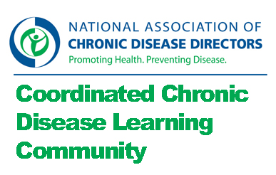

Chronic Disease Self Management Community of Practice

Charge:
- Describe the range of chronic disease self management efforts in state-level chronic disease prevention programs and explore the opportunities for coordination in this kind of programming.
- Identify resources and recommendations for implementation and evaluation of a coordinated approach chronic disease self management interventions.

Monday, March 11th, 2013
- Attending: Dona, Chris, Keith, Jeanne
- Not attending: Liz, Pamela, Stirling

Discussion:
- Communities of Practice
  - Discussion: Reviewed one pager. Reviewed operations.
  - Follow up: Dropbox will be an issue so have Jeanne do email. Include recommendation to use track changes. Jeanne to do a calendar reminder for intermeeting work.
- Chronic disease self management
  - Discussion: What are your questions about Chronic disease self management? What are your questions about the intersection between cdsm and coordinated chronic disease?
    - How many chronic disease programs are working on chronic disease self management?
    - Who else is doing chronic disease self management programs?
    - How does it fit in coordinated chronic disease?
    - Who are you collaborating with (internally/externally)? What is your role?
    - Sometime this is in the state agency on aging and chronic disease does not have the lead?
    - What programs are you doing?
    - Do you have a systems approach?
    - Are you working with health care systems such as health plans or hospitals? Funders? Providers?
    - How many states are working with health plans for reimbursement for implementation?
    - How many states are working with ambulatory care?
    - How many states are working with Federally Qualified Health Centers?
    - How many states are working with patient centered medical homes and using chronic disease self management as a point of patient engagement?
    - What kinds of community agencies are you working with?
    - How many of the community agencies are targeted to high risk populations?
    - Are you working with working with worksite partners?
    - What is your infrastructure in terms of training (master training/t trainer)? How many leaders do you have?
    - Can having master trainer/t trainer in one program be leveraged to offer other programs?
    - What about the role of asthma educators, diabetes educators etc? Capacity and evidence-base?
  - Follow up: Continue brainstorm via email with the large group.
- Framework
  - Discussion: We will need to define a set of questions to answer.
  - Follow up: After the large group has had a chance to add to the brainstorm, Jeanne will send out a prompt to identify 3 priority questions.
- Intermeeting work
  - What: Bios and pictures. Review notes. Add questions to chronic disease management section. Identify three questions you recommend for set of questions to answer.
  - When: Please send to Jeanne on Monday, March 25th.
- Next meeting: Monday April 8th, 2013, 1:00 pm eastern, (866) 453-0947, 9431004

