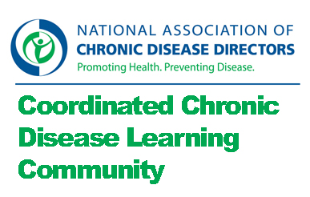

Cross Training Community of Practice

Charge:
- Explore the needs, methods, and tools that exist regarding cross-training chronic disease prevention program staff.
- Identify resources and recommendations for how to implement and evaluate cross-training activities.

Monday, March 25th, 2013
- Attending: Dita, Holly, Judy, Margie, Jeanne
- Not attending: Brian

Discussion:
- Communities of Practice
  - Discussion: Reviewed one pager. Reviewed operations.
  - Follow up: Dropbox may work so we will give it a try. We will also use email for document sharing and Jeanne will set up a web archive.
- Chronic disease self management
  - Discussion: What are your questions about cross training for coordinated chronic disease?
    - Obstacles we face are categorical funding streams, different grant years, and integrated positions?
    - Funding for training?
    - Staffing capacity across the quad FOA.
    - With no funding for coordinated chronic disease how do we continue this work?
    - Skills assessment of the staff – what is necessary to move from program focus to more project focused work.
    - What are the tools that exist for skills and capacity assessment?
    - Risk factor mapping to identify shared risk factors as place to focus coordination work.
    - What are the skills needed to accomplish coordinated chronic disease prevention?
    - Using capacity assessment to identify skill areas for coordinated chronic disease.
    - Finding content to meet training needs and finding a mechanism to offer it.
  - Follow up: Continue brainstorm via email with the large group.
- Framework
  - Discussion: We will need to define a set of questions to answer.
  - Follow up: After the large group has had a chance to add to the brainstorm, Jeanne will send out a prompt to identify 3 priority questions.
- Intermeeting work
  - What: Bios and pictures. Review notes. Identify three questions you recommend for the set of questions to answer.
  - When: Please send to Jeanne on Monday, April 8th.
- Next meeting: Monday April 22nd, 2013, 1:00 pm eastern, (866) 453-0947, 9431004
- Note: No May meeting – just email work in May.

