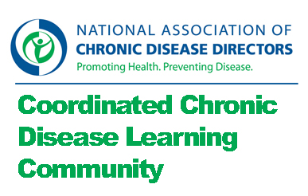

Cross Training Community of Practice

Charge:
- Explore the needs, methods, and tools that exist regarding cross-training chronic disease prevention program staff.
- Identify resources and recommendations for how to implement and evaluate cross-training activities.

Monday, April 22nd, 2013
- Attending: Dita, Judy, Jeanne
- Not attending: Brian, Holly, Margie

Discussion:
- Chronic disease self management brainstorm
  - Discussion: What are your final thoughts about questions on cross training for coordinated chronic disease?
    - How to carve out time to figure out training needs and match training
    - Even with a full time POC, getting time on staff calendars for training is difficult.
    - Making sure what is in process doesn’t get derailed by urgent.
    - Barriers – attitude that this is the flavor of the month.
    - How to make a bigger vision that this is worth while no matter what else come up.
    - How to make it feasible and hands on.
    - How will this make it easier in the long run.
    - NH used parts of the chronic disease competencies, NM did their own based on basic skills.
    - Roots of health inequity training is free but maybe not useful
  - Follow up: NA
- Framework
  - Decision: Bounding questions for this Community of Practice:
    - What are the free and feasible trainings that exist that are applicable to coordination?
    - Is there anything in the competencies that is particularly relevant to this?
  - Follow up: Jeanne will pull together NACDD offers.
    - Send stuff to each other directly and then Jeanne will synthesize.
- Intermeeting work
  - What #1: What trainings already exist? And which parts of the chronic disease competency tool are especially relevant?
    - Jeanne will compile the NACDD training offering.
    - Everyone will share trainings they’ve run across and thoughts on the Chronic Disease Competencies assessment.
  - What #2: How do the trainings we’ve found apply to coordinated chronic disease?
  - When #1: Please send the entire group by Monday, May 13th.
  - When #2: Please send to the entire group by Tuesday, May 28th.
- Next meeting: Monday June 27th 2013, 1:00 pm eastern, (866) 453-0947, 9431004
- Note: No May meeting – just email work in May.

