Webinar on recent ACC/AHA Cholesterol, Hypertension, and Sodium Guidelines:
Implications for Cardiovascular Health: Hypertension

Background: A new guideline for hypertension was recently released in JAMA entitled, “The 2014 Evidence-Based Guideline for the Management of High Blood Pressure in Adults: Report from the Panel Members Appointed to the Eighth Joint National Committee (JNC 8)” (2014 Hypertension Guideline). The new guideline used a standardized approach to evaluate randomized controlled trial (RCT) evidence for the treatment of hypertension. The 2014 Hypertension Guideline used three questions to guide the review and to formulate a set of 9 recommendations (Appendix 2).

Key Points for Consideration:
- No change to hypertension control performance measures are recommended for grantees at this time. Maintain performance goal of <140/90 mmHg for all adults.
- The differences in treatment goals between JNC 7 and the 2014 new guidelines should not overshadow the importance improving hypertension control in the population.
- Several other national and international groups do not have a separate treatment goal for those ≥60 years of age.
- National guidelines for hypertension are expected to be released in late 2014 or early 2015 from a group of professional societies in collaboration with the National Heart, Lung and Blood Institute.
- Public health should capitalize on the national conversation regarding hypertension treatment to:
- Highlight the need to identify those with hypertension currently in care,
- Focus on how the utilization of protocols and/or algorithms can improve hypertension treatment,
- Incorporate team-based care, and
- Use health IT to guide and support hypertension treatment.

Primary Differences between JNC 7 and the 2014 new guidelines
- Treatment goals:
  - JNC 7 – Systolic blood pressure (SBP) <140 mmHg and diastolic blood pressure (DBP) <90 mmHg, with lower targets for those with diabetes (DM) and chronic kidney disease (CKD) (<130/80 mmHg).
  - 2014 Hypertension Guideline – Blood pressure <140/90 for those <60 years and <150/90 for those ≥60 years, and did not include lower targets for those with DM or CKD.
  - Several other guidelines and reports recommend maintaining a treatment goal of <140/90 mmHg and acknowledge the treatment challenges of older adults; some recommended treatment goals for those ≥80 years of age to be <150/90 mmHg (Ref 2-8).
- Initial drug treatment recommendations and recommendations for specific populations:
- JNC 7 - Initial antihypertensive treatment included: thiazide-type diuretics, calcium channel blockers (CCBs), angiotensin converting enzyme inhibitors (ACE), angiotensin receptor blockers (ARB), and beta-blockers.
- 2014 Hypertension Guideline - Initial antihypertensive treatment limited to 4 classes of medications: thiazide-type diuretics, CCBs, ACE, and ARB.
- 2014 Hypertension Guideline included subpopulation recommendations:
  - Nonblack hypertensive population, including those with DM, an ACE, ARB, CCB, or thiazide-type diuretic.
  - Black hypertensive population, including those with DM, a CCB or thiazide-type diuretic.
  - Persons with CKD, initial or add-on antihypertensive therapy with an ACE or ARB.
- Recommendations for follow-up
  - JNC 7 – follow-up and adjustment of antihypertensive therapy at approximately monthly intervals until BP goal reached. More frequent visits for those with stage 2 hypertension or other comorbidities.
  - 2014 Hypertension Guideline – treatment goal should be reached in one month. If not reached, titration or the addition of another medication is recommended. Strategies to dose antihypertensive medications are provided for reference in the guidelines.

Appendix 1: Comparison of 2014 Hypertension Guideline and Recommendations with JNC 7
Topic | JNC 7 | 2014 Hypertension Guideline
Methodology | - Nonsystematic literature review by expert committee including a range of study designs  - Recommendations based on consensus | - Critical questions and review criteria defined by expert panel with input from methodology team  - Initial systematic review by methodologists restricted to RCT evidence  - Subsequent review of RCT evidence and recommendation by the panel according to a standardized protocol
Definitions | - Defined hypertension and prehypertension | - Definitions of hypertension and prehypertension not addressed, but thresholds for pharmacologic treatment were defined
Treatment Goals | - Separate treatment goals defined for “uncomplicated” hypertension and for subsets with various comorbid conditions (diabetes and CKD) | - Similar treatment goals defined for all hypertensive populations except when evidence review supports different goals for a particular subpopulation
Lifestyle Recommendations | - Recommended lifestyle modifications based on literature review and expert opinion | - Lifestyle modifications recommended by endorsing the evidenced-based Recommendations of the Lifestyle Work Group
Drug Therapy | - Recommended 5 classes to be considered as initial therapy but recommended thiazide-type diuretics as initial therapy for most patients without compelling indications (i.e., diabetes, CKD, heart failure, myocardial infarction, stroke, and high CVD risk  - Included a comprehensive table of oral antihypertensive drugs including names and usual dose range | - Recommended selection among 4 specific medication classes (ACEI or ARB, CCB, diuretics) and doses based on RCT evidence  - Recommended specific medication classes based on evidence review for racial, CKD, and diabetic subgroups  - Panel created a table of drugs and doses used in the outcome trials
Scope of topics | - Addressed multiple issues (blood pressure measurement methods, patient evaluation components, secondary hypertension, adherence to regimens, resistant hypertension, and hypertension in special populations) based on literature review and expert opinion | - Evidence review of RCTs addressed a limited number of questions, those judged by the panel to be of highest priority
Review process prior to publication | - Reviewed by the National High Blood Pressure Education Program Coordinating Committee, a coalition of 39 major processional, public and voluntary organizations and 7 federal agencies | - Review by experts including those affiliated with professional and public organizations and federal agencies; no official sponsorship by any organization should be inferred
ACEI: angiotensin-converting enzyme inhibitor; ARB: angiotensin receptor blocker; CCB: calcium channel blocker; CKD: chronic kidney disease; CVD: cardiovascular disease; JNC: Joint National Committee; RCT: randomized controlled trial
JAMA. 2013. doi:10.1001/jama.2013.284427 (Table 1)
Appendix 2: 2014 new guidelines Recommendations
Recommendations 1 – 5
Population | When to initiate treatment:
General population ≥60 years | At SBP ≥150 mm Hg or DBP ≥90 mm Hg and treat to a goal SBP <150 mm Hg and goal DBP <90 mm Hg | Strong Grade A
General population <60 years | At DBP ≥90 mm Hg and treat to a goal DBP <90 mm Hg. (For ages 30-59 years, Strong Recommendation – Grade A; For ages 18-29 years, Expert Opinion – Grade E) | Grade A / E
General population <60 years | At SBP ≥140 mm Hg and treat to a goal SBP <140 mm Hg. | Expert Opinion Grade E
≥18 years with chronic kidney disease | At SBP ≥140 mm Hg or DBP ≥90 mm Hg and treat to goal SBP <140 mm Hg and goal DBP <90 mm Hg. | Expert Opinion Grade E
≥18 years with diabetes | At SBP ≥140 mm Hg or DBP ≥90 mm Hg and treat to a goal SBP <140 mm Hg and goal DBP <90 mm Hg. | Expert Opinion Grade E
Recommendations 6-8
Population | Class of initial antihypertensive treatment:
Non-black population, including those with diabetes | Should include a thiazide-type diuretic, calcium channel blocker (CCB), angiotensin-converting enzyme inhibitor (ACEI), or angiotensin receptor blocker (ARB). | Moderate Grade B
Black population, including those with diabetes | Should include a thiazide-type diuretic or CCB. (For general black population: Moderate Recommendation – Grade B; for black patients with diabetes: Weak Recommendation – Grade C) | Varies
≥18 years with chronic kidney disease | Initial (or add-on) antihypertensive treatment should include an ACEI or ARB to improve kidney outcomes. This applies to all CKD patients with hypertension regardless of race or diabetes status. | Moderate Grade B
Recommendation 9
The main objective of hypertension treatment is to attain and maintain goal BP. If goal BP is not reached within a month of treatment, increase the dose of the initial drug or add a second drug from one of the classes in recommendation 6 (thiazide-type diuretic, CCB, ACEI, or ARB). The clinician should continue to assess BP and adjust the treatment regimen until goal BP is reached. If goal BP cannot be reached with 2 drugs, add and titrate a third drug from the list provided. Do not use an ACEI and an ARB together in the same patient. If goal BP cannot be reached using only the drugs in recommendation 6 because of a contraindication or the need to use more than 3 drugs to reach goal BP, antihypertensive drugs from other classes can be used. Referral to a hypertension specialist may be indicated for patients in whom goal BP cannot be attained using the above strategy or for the management of complicated patients for whom additional clinical consultation is needed. |  | Expert Opinion Grade E
JAMA. 2013. doi:10.1001/jama.2013.284427

Appendix 3: 2014 Hypertension Guideline Management Algorithm
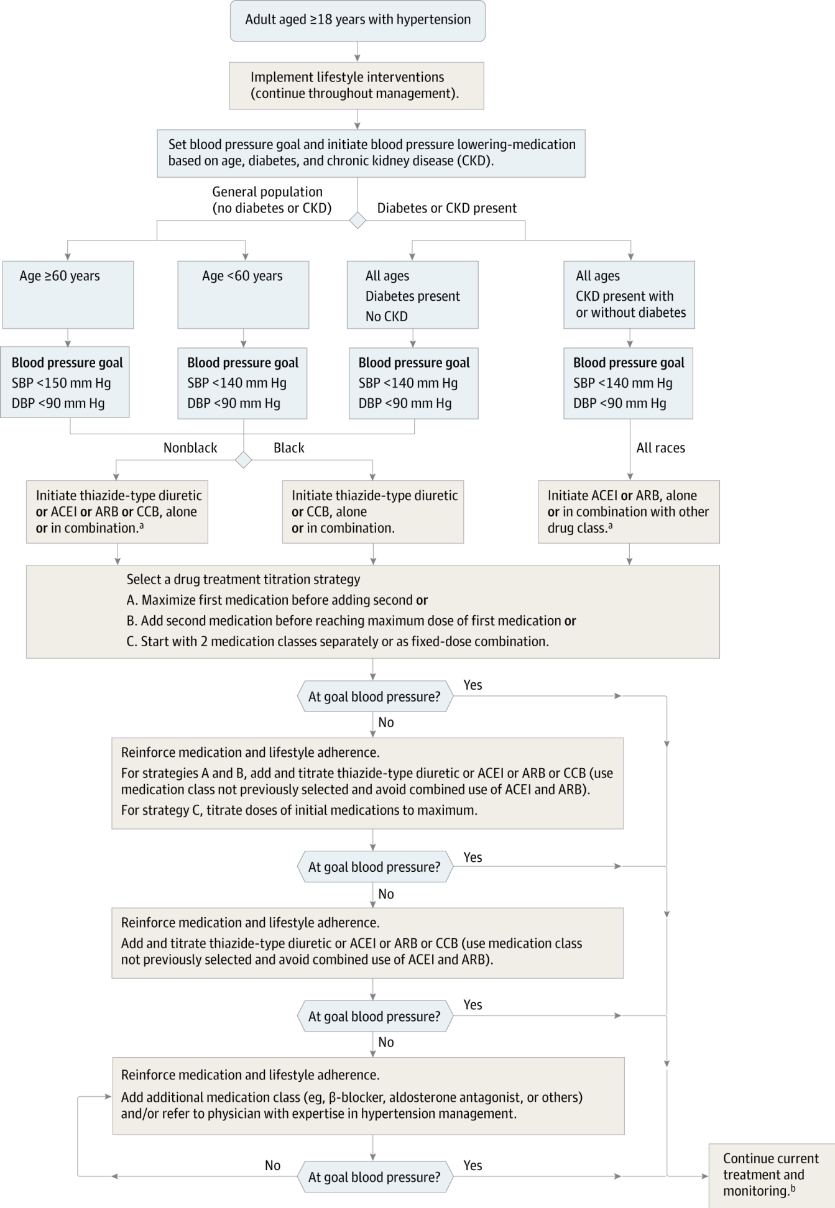

JAMA. 2013 doi:10.1001/jama.2013.284427

References
- James PA, Oparil S, Carter BL, et al. The 2014 Evidence-Based Guideline for the Management of High Blood Pressure in Adults: Report From the Panel Members Appointed to the Eighth Joint National Committee (JNC 8). JAMA. 2013. doi:10.1001/jama.2013.284427.
- Peterson ED, Gaziano J, Greenland P. Recommendations for Treating Hypertension: What Are the Right Goals and Purposes?. JAMA. 2014;311(5):474-476. doi:10.1001/jama.2013.284430.
- Wright JT, Fine LJ, Lackland DT, et al. Evidence Supporting a Systolic Blood Pressure Goal of Less Than 150 mm Hg in Patients Aged 60 Years or Older: The Minority View. Archives of Internal Medicine. Published online 14 January 2014 doi:10.7326/M13-2981.
- Mancia G, Fagard R, Narkiewicz K, et al; Task Force Members. 2013 ESH/ESC Guidelines for the management of arterial hypertension: the Task Force for the management of arterial hypertension of the European Society of Hypertension (ESH) and of the European Society of Cardiology (ESC). J Hypertens. 2013;31:1281-357. [PMID: 23817082]
- Canadian Hypertension Education Program. 2013 Canadian Hypertension Education Program (CHEP) Recommendations. Markham, Ontario, Canada: Hypertension Canada; 2012. Accessed at www.hypertension.ca/chep-recommendations on 31 December 2013.
- National Institute for Health and Clinical Excellence. Hypertension: clinical management of primary hypertension in adults. Clinical guidelines: methods, evidence and recommendations. London: National Institute for Health and Clinical Excellence; 2011.
- Aronow WS, Fleg JL, Pepine CJ, et al. ACCF/AHA 2011 expert consensus document on hypertension in the elderly: a report of the American College of Cardiology Foundation Task Force on Clinical Expert Consensus documents developed in collaboration with the American Academy of Neurology, American Geriatrics Society, American Society for Preventive Cardiology, American Society of Hypertension, American Society of Nephrology, Association of Black Cardiologists, and European Society of Hypertension. J Am Coll Cardiol. 2011;57:2037-114. [PMID: 21524875]
- Weber MA, Schiffrin EL, White WB, et al. Clinical Practice Guidelines for the Management of Hypertension in the Community: A Statement by the American Society of Hypertension and the International Society of Hypertension. J Clin Hypertens (Greenwich). 2013. [PMID: 24341872]

