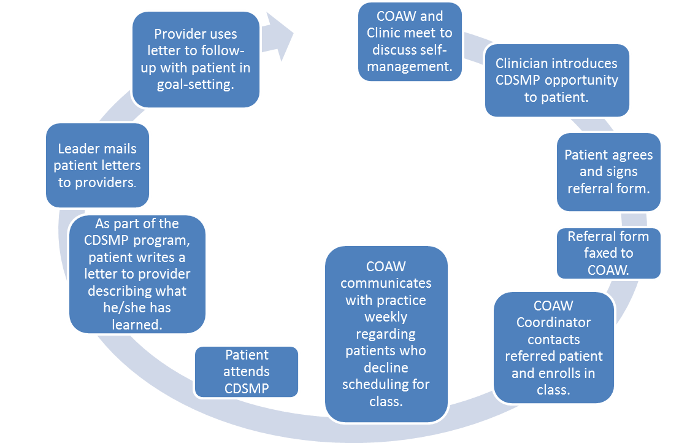
Consortium for Older Adult Wellness
2575 S. Wadsworth Blvd.
Lakewood CO 80227
303-984-1845
888-900-2629(COAW)
www.coaw.org
Referral Process

This Form has been developed by the Consortium for Older Adult Wellness.
Please reference COAW in all reprints or revisions.

