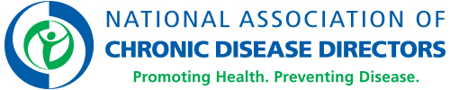

Share your feedback with us!

We are looking for quotes that we can share in our publicity materials about the value NACDD offers in helping to host meetings and events like this one. Please share your thoughts with us on why NACDD’s work and mission to prevent chronic disease and promote health is important to you. By signing this form, you agree that we can use your quote for our publicity purposes and attribute it to you.

Feel free to write whatever comes to mind, but if you need a few prompts, here are some questions to answer:

- NACDD does important work because…
- NACDD is a great partner because…
- We could not do XXX without NACDD’s support because…

Date
Signed by (please print and sign name)

