DESIGN THINKING

You probably have heard the term “design thinking.” Although there are many variations of the Design Thinking process, all variants embody the same principles. Here you can see the five-phase model proposed by the Hasso-Plattner Institute of Design at Stanford, which is also known as d.school. The five phases of Design Thinking, according to d.school, are as follows:
- Empathize with your users by uncovering their wants and needs through conversations and observations. Here, the emphasis is on immersion in user experience as opposed to the use of traditional survey research methodology.
- Define your users’ needs, their problems, and your insights. This is done by developing user-personas and analyzing pain points and challenges users face.

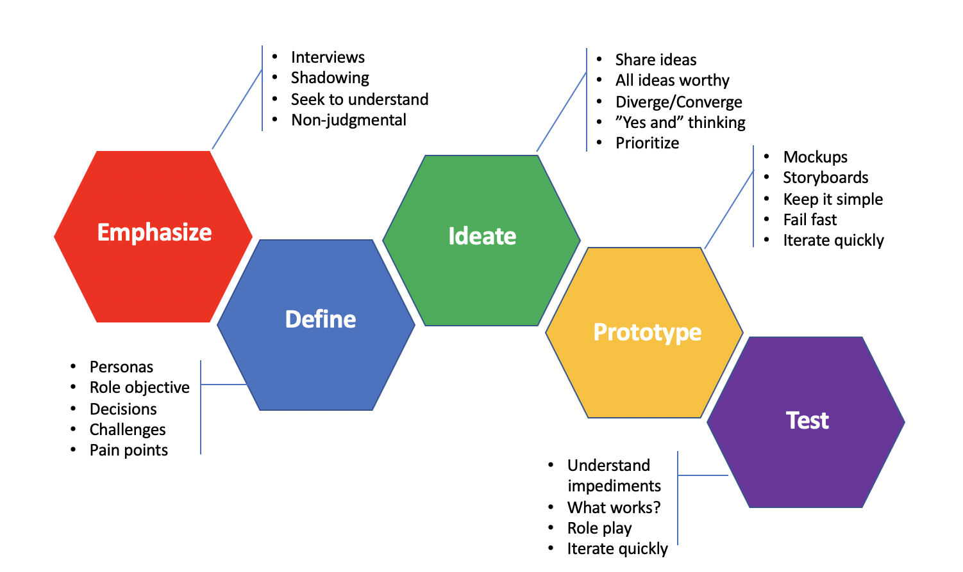
Figure 1. Design Thinking Process

- The third phase is ideation. During this phase, the team challenges assumptions and creates ideas for innovative solutions.
- In the prototype phase, the team starts to create and prototype solutions.
- Then, the team tests them with audience members in an iterative way. This means that the design team continuously uses the results of testing to review, question, and improve their initial assumptions, understandings, and results. Results from the final stage of the initial work process inform understanding of the problem, help determine the parameters of the problem, enable the team to redefine the problem, and, perhaps most importantly, provide the team with new insights so they can see any alternative solutions that might not have been available with the previous level of understanding.
Design thinking, also called Human-Centered Design (HCD), appears well-suited for addressing issues of population health. Over the last decade there has been an increasing number of design thinking applications to improve population-level health outcomes. For example, HCD has been leveraged, among other causes, to create a wearable breast pump, develop video games to build children’s emotional strength, reduce childhood obesity, improve sleep for athletes, and empower women to prevent HIV.

Just as it is applied to other sectors, the design thinking approach in a public health context focuses on a deep dive into the practices of the community. This designs a solution coming from a rich empathy for a community’s particular situation. HCD starts small so that you can prototype and test solutions until you can figure out how the population is influenced by the specific messaging you have developed and where you can focus your messaging. First, start in a small community, find solutions that are appropriate to that community, and then see how it is applicable to other communities and whether it can be scaled.

In addition, an article published by Centers for Disease Control and Prevention (CDC) suggests that one area where Design Thinking could be especially useful is in designing interventions for underserved populations whose needs may be overlooked by other approaches. The study gives an example of an education tool to enhance long-acting contraceptive use in a clinic serving mostly African American patients, where they were included early in the usability testing process to ensure the tool met their needs. Several changes were made as a result, such as including more peer testimonials, which likely increased the tool’s impact and relevance. The study concluded that Design Thinking could also pair well with strategies that prioritize the inclusion of users in service of reducing health disparities, such as community-based participatory research.

Design thinking can also be a leadership philosophy. According to an article published by MIT Management Review, “It is hard to pick up a current business publication without reading about the imperative to change. The world, this line of argument suggests, is evolving at an ever-faster rate, and organizations that do not adapt will be left behind. Left silent in these arguments is which organizations will drive that change and how they will do it.”

The authors charge that although many organizations strive for continuous change and learning, few actually achieve those goals. According to the authors, the ability to identify critical problems is the “most underrated skill” in leadership. Not only can adopting design thinking help you identify organizational problems correctly, by incorporating empathy, but it can also help you solve them.

Jesse Himsworth, a contributor to Forbes, argues that design thinking is about collaboration – bringing perspectives from across your agency and partner organizations – harnessing collective brain power to produce optimal solutions. Design thinking encourages individuals to put their best foot forward and for groups to come together in an effort to innovate as a team. Harnessing the collective brainpower of your agency and partners will ensure you come up with multiple prototypes to test, presenting more opportunities for optimization as you work toward a final solution. In other words, when you prioritize design thinking as a leader, you make the most of the cross-functional talent at your fingertips.

The principle of empathy has a tremendous impact on leadership. Here empathy applies to your external and internal audiences. When it comes to external audiences – communities that we serve -- if you're going to your colleagues, your agency leaders, “and you have the voice of your community members in your pocket, that supersedes any assigned power in that organization. It's hard to refute the findings of a two-week immersive exploratory process with community members. And, you'll be a visionary,” says Matthew Kressy, Director and Co-Founder of MIT Integrated Design & Management.

From the internal audience point of view, empathy can apply to getting to know your team. Your team members are very different people with different motivations and passions. Observing your team members can help you better tailor your approach to different members. According to Anthony Howard, author of Humanize, a book about human-centered leadership, this is about “putting people first.” This means “understanding all of the people you are touching as a leader, and understanding the impact that you are having on them. Are you, for example, enhancing or diminishing their life? Are you helping them become a better person, so that they can be the best version of themselves? This gives leadership a moral dimension, as it focuses on what is good and right, while building on the technical aspects of leadership, such as strategic capability, exercising influence, and enrolling people in a vision for the future.”

Prototyping and testing also applies to leadership. Leaders should not be afraid to try different solutions to organizational problems and test them. Prototyping solutions assumes failure. We usually resist failure – we are hard-wired to avoid it. But failure should be actively pursued in prototyping. If the prototype runs smoothly, nothing new will be learned, yet prototyping is all about learning. According to Hilberts, van Dijk, and Benammar, “failures are to be expected, and innovation leadership even seeks them out, as long as you get feedback on what went wrong. Fail often and fail forward – always make sure to learn from the failure to move forward with an improved version. Also, fail as early as possible and as cheaply as possible.”

APPLY DESIGN THINKING IN YOUR NEXT PARTNER MEETING
Consider applying some of these activities into your meetings to get your team to use Design Thinking techniques.

Build Empathy: Impromptu Networking
Take about 15 minutes for participants to meet in groups of two or four and introduce themselves to each other and answer the question: “What big challenge do you bring to this gathering? What do you hope to get from and give to this group or community?” By the end, each person will talk to about four people and learn something new about their partners.

Impromptu Networking allows participants to quickly gain new perspectives on the people they’ll be working with on a project/collaboration.

Ideate: SCAMPER

In your next brainstorming meeting, try using SCAMPER. SCAMPER stands for:
- Substitute.
- Combine.
- Adapt.
- Modify.
- Put to another use.
- Eliminate.
- Reverse.

You use the tool by asking questions about an existing product or service, using each of the seven prompts above to develop questions. These questions help you come up with creative ideas for developing new products, and for improving current ones.

Click here to learn more about SCAMPER.

