Additional Online Communications Tools and Resources

The Communications department has compiled a list of royalty-free or open-source graphics, images, and audio databases and resources to support your communications projects.
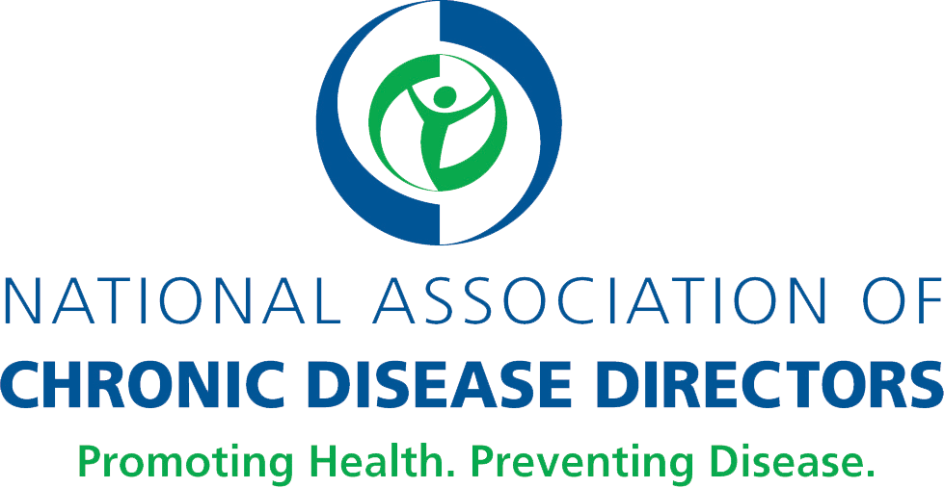

Stock image websites
- Stock.XCHNG (freeimages.com): Stock.XCHNG has more than 50 pages of pharmacy-oriented healthcare photos.
- Dreamstime (dreamstime.com): There are more than 15,000 health care photos that emphasize natural health and healthy living.
- Unsplash (unsplash.com): High-resolution photo collections that highlight healthy foods and health, fitness and wellness.
- StockSnap.io (stocksnap.io): StockSnap.io features high-resolution photos that focus on landscape, outdoors and exercise.
- Public Health Image Library (https://phil.cdc.gov/phil/home.asp): CDC’s public health image library includes images of influenza, natural disasters, environmental health, bioterrorism, everyday activities, EM imagery, health behaviors, public health in action, laboratory science, and developmental milestones.

Vector art
- Vecteezy (vecteezy.com): Vector images allow for more flexibility because they can be resized without losing sharp resolution.

Audio libraries
- YouTube Audio Library (youtube.com/audiolibrary/music): YouTube Audio Library has different types of audio files, ranging from background music to sound effects.
- Free Stock Music (https://www.freestockmusic.com/): Audio files include cinematic music, easy listening, and other categories such as classical and corporate.

Graphic design templates
- Canva (canva.com): Canva allows users to use drag-and-drop features and professional layouts in design graphics.

