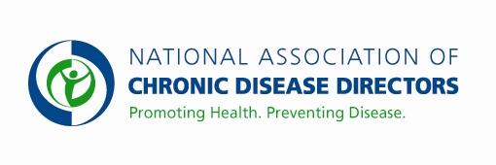

Note Submit completed form to eval@chronicdisease.org, Please allow 30 business days for approval.

The purpose of the form is to advise NACDD about speakers prior to an event.

Submission Date:

Submitter’s Name:

Program #:

Program Name:

Date of Speaking Engagement Event:

Speaker’s Name:

Topic of Subject:

Speaker Fee Amount:

