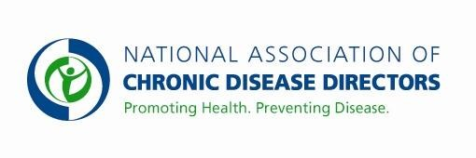
NATIONAL COMPREHENSIVE CANCER CONTROL PROGRAM FY 2020 APPROPRIATIONS FACT SHEET
CENTERS FOR DISEASE CONTROL AND PREVENTION

FY 2018 | FY 2019 | FY 2020 President’s Budget | FY 2020 Request
$19,675,000 | $19,675,000 | $67,143,000** | $50,000,000
** The FY 2020 request reduces funding for the Cancer Prevention and Control Program by $34 million. It eliminates funding for the Colorectal, Prostate, Ovarian and Skin Cancer programs.

CDC’ s National Comprehensive Cancer Control Program
The CDC National Comprehensive Cancer Control Program (NCCCP) establishes comprehensive cancer control (CCC) coalitions, defines cancer priorities in each state and provides the evidence base for effective cancer prevention and control. Minimal funding is provided to CDC to support all 50 states, the District of Columbia, 6 U.S. Associated Pacific Island Jurisdictions and Puerto Rico, and 8 tribes or tribal groups. Additional resources would enhance the national, state and local ability to prevent and control cancer. Specifically, increased funding would support enhanced primary prevention efforts, increased access to early detection and quality treatment, and efforts to improve the quality of life of cancer survivors.

The NCCCP provides a strategic, coalition-based approach to reduce the number of illnesses and deaths caused by emphasizing primary prevention; coordinating early detection and treatment interventions; addressing the public health needs of cancer survivors; implementing policies to sustain cancer control; eliminating health disparities to achieve health equity; and ensuring impact and use of evidence and evaluation. Program activities include efforts to:
- increase colorectal cancer screening rates to 80% nationwide, including in every single community;
- increase HPV vaccination coverage rates to prevent HPV-associated cancers that currently cause nearly 34,000 cancer deaths in men and women each year;
- increase surveillance efforts to better understand the needs of cancer survivors and facilitate access to community resources to support survivor needs;
- increase activities to improve cancer health outcomes among populations who experience poorer health outcomes than most; and
- sustain healthy, effective cancer coalitions.

Additional funding would significantly increase NCCCP awardees’ capacity in these priority areas.

Basic Facts About Cancer
- One in three Americans will be diagnosed with cancer in their lifetime.
- Cancer is the second leading cause of death in the United States, resulting in nearly 600,000 deaths in 2015, the most recent year for which complete incidence data are available.
- Cancer kills more American Indian, Alaska Natives, Asian/Pacific Islander and Hispanic
Americans than any other disease, regardless of age.
- The number of Americans living with a previous diagnosis of cancer, currently estimated at almost 15.5 million, is on the rise.
- Cancer cost the United States an estimated $157 billion in medical expenses in 2010, and this number is expected to increase substantially over the next 10 years.

Visit the CDC website for NCCCP Success Stories.
Contact: Amy Souders, Cornerstone Government Affairs. (202) 488-9500 or asouders@cgagroup.com

