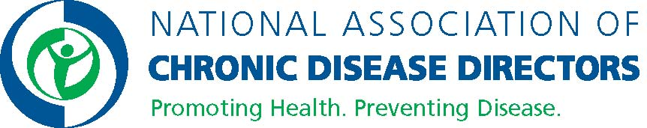

Public Health Subject Matter Expert
Overview:
The Public Health Subject Matter Expert will provide technical assistance and support to organizations funded by the Centers for Disease Prevention and Control to implement the National Diabetes Prevention Program (DPP) lifestyle change program for priority populations in underserved areas. The Public Health Subject Matter Expert will coordinate and work with a team to provide resources (e.g. newsletter and success stories) and interactive peer-to-peer offerings (e.g. discussion forums, communities of practice, face to face meetings, webinars) on various topics related to the National DPP lifestyle change program.
The Public Health Subject Matter Expert will support other NACDD projects related to other chronic disease topics such as cancer, arthritis, and heart disease and stroke.
Scope of Work:
- In coordination with CDC and NACDD Consultants, the SME will be responsible for coordinating Communities of Practice (CoPs) for organizations funded by the Centers for Disease Control and Prevention to implement the National DPP lifestyle change program in underserved areas. The purpose of the CoPs is to enhance peer to peer sharing and learning and increase the capacity of organizations to achieve progress on type 2 prevention strategies/interventions.
- In coordination with CDC and NACDD Consultants, the SME will coordinate discussion forums on various topics to support peer-to-peer learning and support between funded organizations.
- As a team member, provide strategic and technical support to other team members coordinating activities such as trainings and newsletters.
- Provide administrative and strategic support for the NACDD and/or project assigned, including organizing meetings and on-site meetings with partners/members.
- Provide generalized and specific technical assistance and information to organizations; maintain knowledge about the current science of and best practices for public health approaches to diabetes prevention and control.
- Maintain positive working relationships with organizations and CDC.
- Assist in the evaluation of project activities.
- Manage multiple and numerous project activities to meet project goals/deliverables;
- Able to demonstrate subject matter expertise;
- Compile and present quality information in form and content;
- Facilitate meetings, focus groups, workshops, and/or trainings;
- Identify issues and make recommendations;
- Prepare reports (written reports, oral presentations, or postings on websites) including but not limited to:
  - Chief Executive Officer and/or Board reports (i.e. dashboard reports)
  - Association materials and publications (NACDD annual report, e-bulletin, etc.)
  - Peer reviewed journals
  - Evaluation of conferences and other NACDD training events
  - Assist with program progress reports to CDC or other program funders and stakeholders
- Assist with grant application submission and other proposals for funding. This includes but is not limited to writing, compiling of information, and/or coordination of activities.
- Performs other duties as assigned or as necessary to achieve program’s goals and objectives.

Knowledge, Skills, and Abilities:
- Masters degree in Public Health, Public Health Administration or related field with minimum of five years of experience in the public health field
- Knowledge of and experience of using the National Diabetes Prevention Program (DPP) lifestyle change program
- Knowledge of the Diabetes Prevention Recognition Program (DPRP) and how organizations can apply to become a National DPP CDC-recognized organization
- Knowledge of CDC National DPP lifestyle change program and the evidence base that supports it
- General knowledge of business case, cost effectiveness and return on investment of the National DPP
- Knowledge of designing and implementing disease prevention/health promotion benefits for employers.
- Knowledge of prediabetes and diabetes screening guidelines
- Knowledge of screening systems/tools to identify those at risk and use of recommended tests for diagnosing prediabetes and diabetes.
- Experience in working with health care providers to set up screening, testing and referral systems
- Knowledge of payment and delivery models for disease prevention programs
- Ability to present information and provide technical assistance about the National DPP to various audiences
- Strong facilitation skills
- Strong interpersonal skills and ability to work independently as well as with a team
- Effective communication, and organizational skills; attention to detail is required
- Ability to effectively present information and respond to questions from senior management, staff, partners, CDC, and consultants
- Strong project management, prioritization, and planning skills, with demonstrated success producing high-quality deliverables on time and within budget
- Intermediate to advanced experience with Microsoft Office Programs (i.e. Word, Excel, Outlook, PowerPoint) is required
- Takes initiative after initial direction received and plans and implements projects from start to finish without significant supervision
- Dedicated to collaboration and a teamwork culture with ability to draw upon other team members’ skills and experiences to enable the strongest products possible
- Strategic planning skills
- Strong writing skills
- Creative in problem solving and approaches to project implementation
- Proactive in providing technical assistance and support that drives projects forward to best meet project goals and technical assistance organization’s needs
- Exhibits flexibility, particularly in working with organizations who have demanding schedules and multiple priorities.

Classification: Contractual/Consultant status

Contract Duration: Project contract is 1 year; project duration could be multiple years

Annual Compensation: TBD

Benefits: There are no benefits associated with this position

How to Apply: For more information about NACDD visit www.chronicdisease.org. Applicants must send a resume to the following email address: careers.nacdd@chronicdisease.org.

While we sincerely appreciate all applications, only those candidates selected for interview will be contacted.

